**Face Recognition**

**Introduction:**

For this project I used Fastapi, Because the response time of Fastapi is better than Flask and Django. It’s now popular in worldwide. And so, there is a library called face recognition for face recognition in project.

The key features of Fastapi are:

* **Fast**: Very high performance, on par with **NodeJS** and **Go**
* **Fast to code**: Increase the speed to develop features by about 200% to 300%. *
* **Fewer bugs**: Reduce about 40% of human (developer) induced errors. *
* **Intuitive**: Great editor support. Completion everywhere. Less time debugging.
* **Easy**: Designed to be easy to use and learn. Less time reading docs.
* **Short**: Minimize code duplication. Multiple features from each parameter declaration. Fewer bugs.
* **Robust**: Get production-ready code. With automatic interactive documentation.

**Step 1:**

**Libraries:**

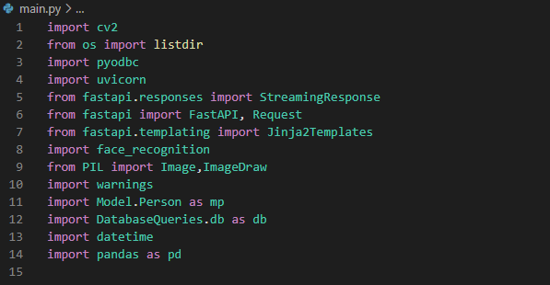

**Face Encodings:**

In this step, all data from images folder loaded into imagesList and then using for loop read data one by one and perform operations like load_image_file, face_encodings and save them in list which created before the function.

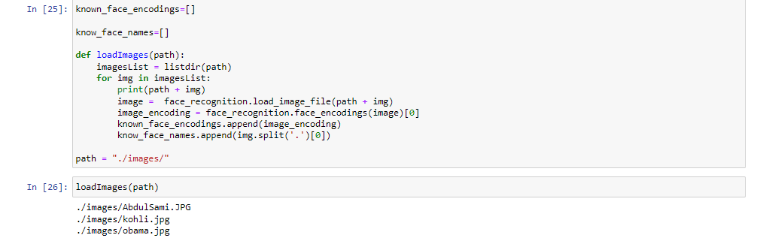**Face Testing:**

Moreover, in testing phase machine capture image from web camera then load into load_image_file after that test_image pass through face_locations, face_encodings function and finally compare with data which I stored previous.

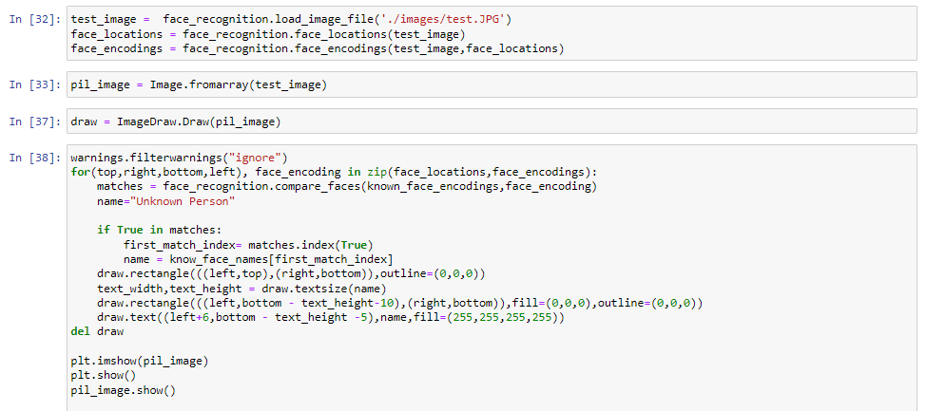

**Database:**

Since, I have to connect with database for data storage of person when he comes or goes. For this purpose I used pyodc library which helps me a lot to do database operations like retrieving data.

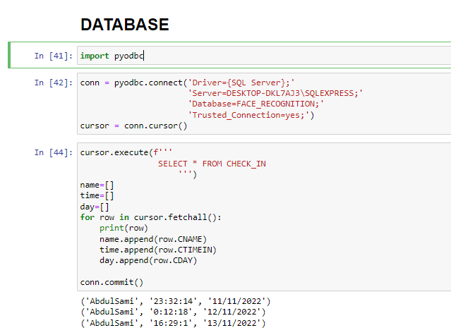

**Export Data To CSV:**

Whenever you use database like SQL Server then major problem is to share data with other people so that’s why the process to retrieve csv file is very useful in this case. However, in python there is Pandas library which help us to create data frame and perform a bunch of operations for data cleaning. Pandas gives us a function called tocsv which convert data frame to csv file.

